PRIVACY NOTICE
for
Pupils
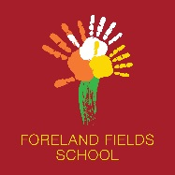

The Privacy notice below has been designed for parents and carers to talk through and discuss at the appropriate level for their child. A symbolised version will also be taught in school.
Foreland Fields School keeps information about you so that we can help you learn and keep you safe.
- We need to know how old you are, where you live and who to phone in an emergency.

- We need to know how much you have learnt so we can plan lessons for you.

- We need to know how to keep you healthy so some pupils have a Health Care
Plan that tells us which medicine you might need and how to help you in an emergency.

- We need to know any information that helps make sure you are safe both at school and at home.

- We have to keep all of this information safe on computers and on paper, and when we don’t need it anymore we must get rid of it safely.

If you want to know more about the information we have kept about you then you can speak to Shelley Furlong, who is our School Information Champion.

