23rd February 2024

Dear Parents and Carers,

RE: Royal Academy of Arts Young Artists’ Summer Show 2024

One of our parents suggested the school being involved in this year’s Royal Academy Young Artist Summer Show 2024 competition. This is a wonderful opportunity for children to have their work showcased online and at a prestigious London gallery.

The Young Artists’ Summer Show offers primary and secondary students the exciting opportunity to exhibit their artwork at the Royal Academy both on site and online. For more information visit: https://youngartists.royalacademy.org.uk/

The competition is open to all children aged 4-19. There are no restrictions on what the children can make, 2D or 3D works and this year there is no theme. The Royal Academy only ask that works be original and do not infringe upon any copyrights. Children are encouraged to have fun creating! Prizes will be awarded for inspiring artworks from each Key Stage. There will also be a People’s Choice award, where members of the public can vote for their favourite artwork.

Children will be completing work in school which will be considered for submission however, if a child completes any work at home that parents would like included please send them in to school.

Submissions need to be received by Friday 22nd March at the latest. All artworks should be delivered to the school office with an accompanying parental consent form and a short description about the artwork. Any works handed in without parental consent will not be submitted. A consent form has been sent home with this letter however, spare forms can be collected from the school office or, on request, sent home via email. We will be contacting parents for the completion of consent forms for school-based submissions nearer the time.

Yours sincerely
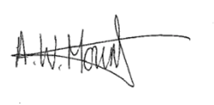
Adrian Mount
Headteacher

